**DIGITAL LOGIC DESIGN CEP REPORT (CS-220)**

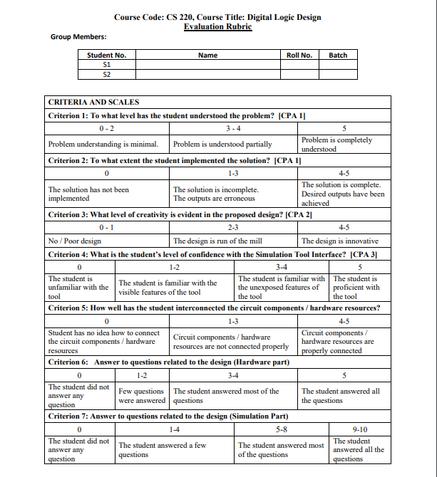

**Unlock Combination Pair Selected:**

As the 1st Roll No is 31 and the 2nd Roll No is 10, so 31+10=41. According to the Rule, as our least significant digit of 41 is 1, so the Unlock Combination Pairs are:

1. 1101

2. 0110

**State Diagram:**

0/01

0/00 0/00 1/00

0/00 0/00 1/00 1/00

1/00

0/00 1/00 0/00

1/10

0/00

1/00

**State Assignment:**

No. of States = 7

No. of Flipflops needed = Log2N = Log27 = 3

A = 000

B = 001

C = 010

D = 011

E = 100

F = 101

G = 110

**State Table:**

|  |  |  |  |  |  |  |  |  |  |  |  |
| --- | --- | --- | --- | --- | --- | --- | --- | --- | --- | --- | --- |
| Present State | | | Input | Next State | | | Output | | Flipflop Inputs | | |
| Q2(t) | Q1(t) | Q0(t) | X | Q2(t+1) | Q1(t+1) | Q0(t+1) | Y1 | Y0 | D2 | D1 | D0 |
| 0 | 0 | 0 | 0 | 0 | 0 | 1 | 0 | 0 | 0 | 0 | 1 |
| 0 | 0 | 0 | 1 | 1 | 0 | 0 | 0 | 0 | 1 | 0 | 0 |
| 0 | 0 | 1 | 0 | 0 | 0 | 0 | 0 | 0 | 0 | 0 | 0 |
| 0 | 0 | 1 | 1 | 0 | 1 | 0 | 0 | 0 | 0 | 1 | 0 |
| 0 | 1 | 0 | 0 | 0 | 0 | 0 | 0 | 0 | 0 | 0 | 0 |
| 0 | 1 | 0 | 1 | 0 | 1 | 1 | 0 | 0 | 0 | 1 | 1 |
| 0 | 1 | 1 | 0 | 0 | 0 | 0 | 0 | 1 | 0 | 0 | 0 |
| 0 | 1 | 1 | 1 | 0 | 0 | 0 | 0 | 0 | 0 | 0 | 0 |
| 1 | 0 | 0 | 0 | 0 | 0 | 0 | 0 | 0 | 0 | 0 | 0 |
| 1 | 0 | 0 | 1 | 1 | 0 | 1 | 0 | 0 | 1 | 0 | 1 |
| 1 | 0 | 1 | 0 | 1 | 1 | 0 | 0 | 0 | 1 | 1 | 0 |
| 1 | 0 | 1 | 1 | 0 | 0 | 0 | 0 | 0 | 0 | 0 | 0 |
| 1 | 1 | 0 | 0 | 0 | 0 | 0 | 0 | 0 | 0 | 0 | 0 |
| 1 | 1 | 0 | 1 | 0 | 0 | 0 | 0 | 1 | 0 | 0 | 0 |
| 1 | 1 | 1 | 0 | X | X | X | X | X | X | X | X |
| 1 | 1 | 1 | 1 | X | X | X | X | X | X | X | X |